1 / 37

**Zoo - Web Design - CA2**

Link to our deployed website:

<https://sergio-oliveira-br.github.io/NCI-CA-Web-Design/>

<https://github.com/sergio-oliveira-br/NCI-CA-Web-Design>

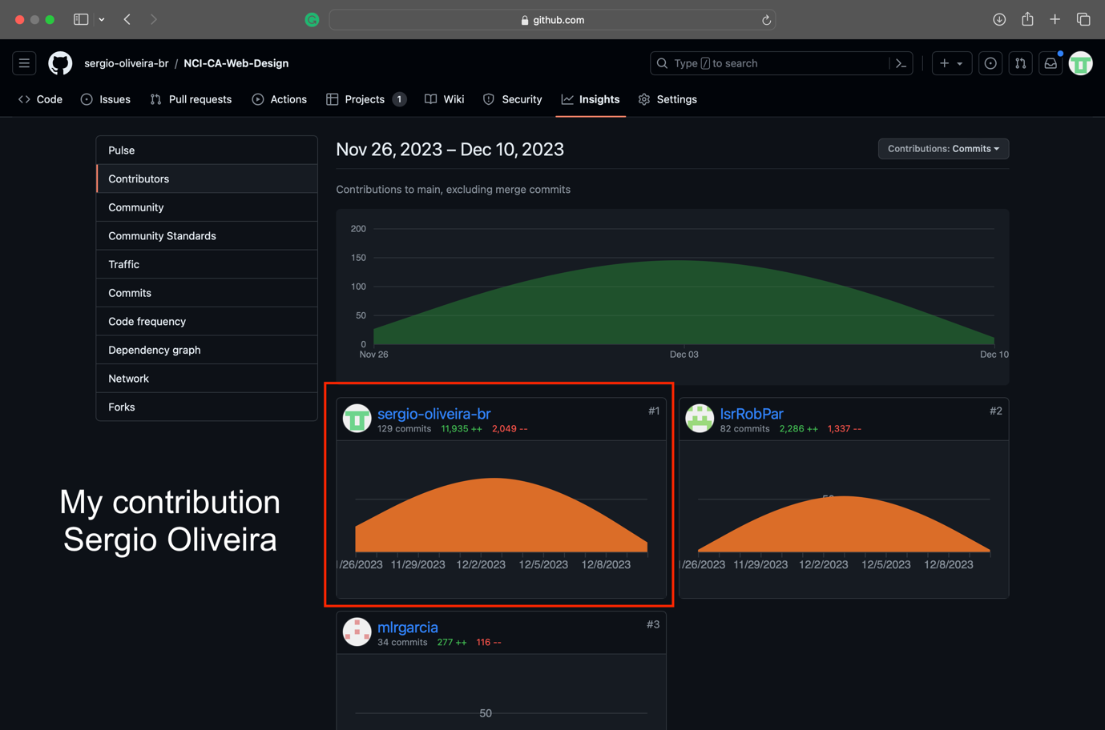

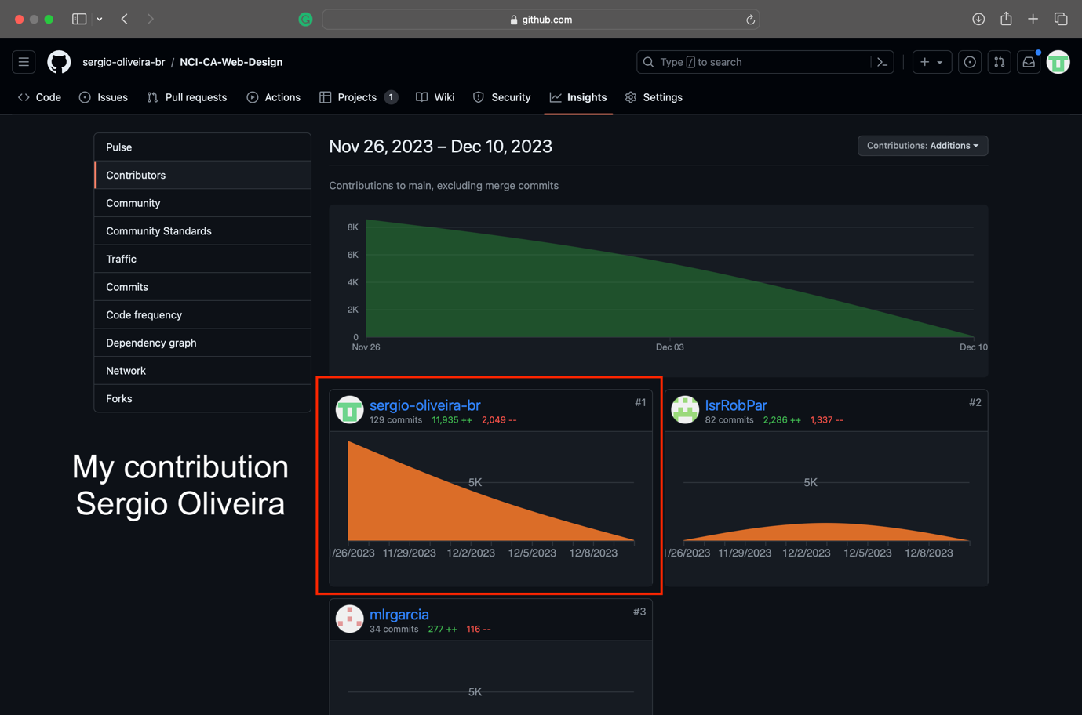

Page developed by Israel Parma (Home)

My contribution was only on JavaScript.

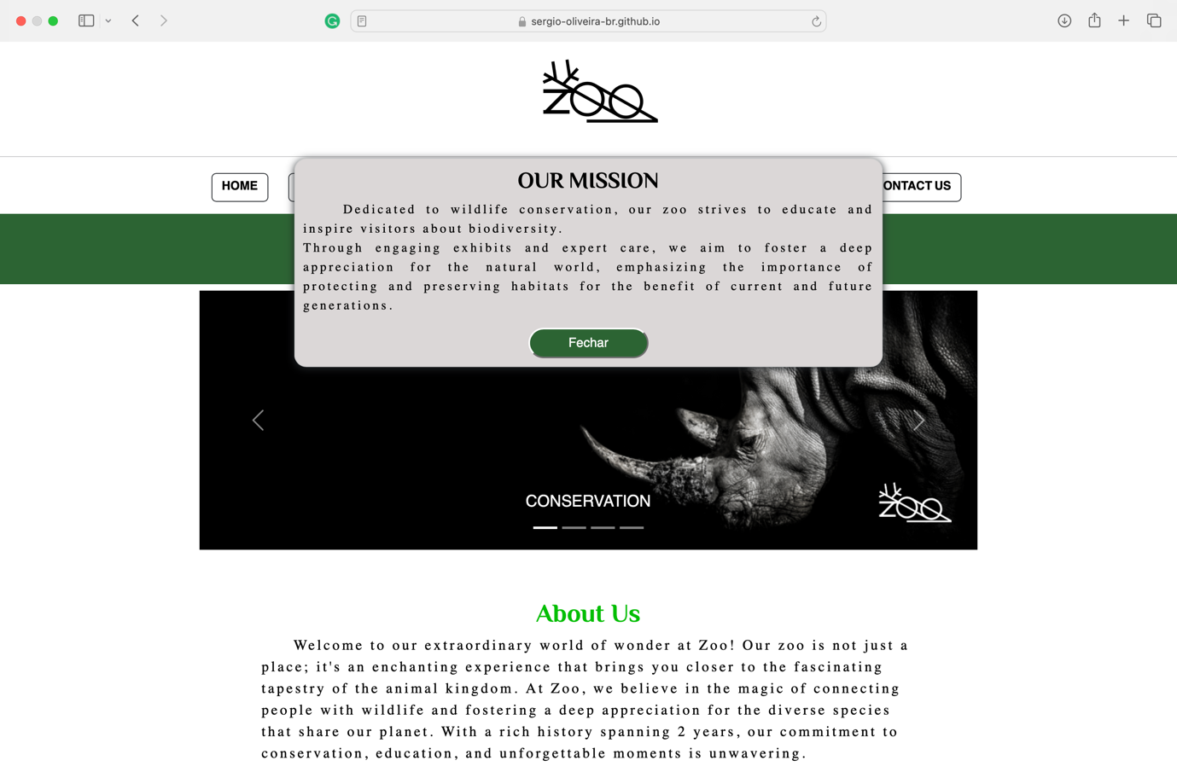

Page developed by Israel Parma (Home)

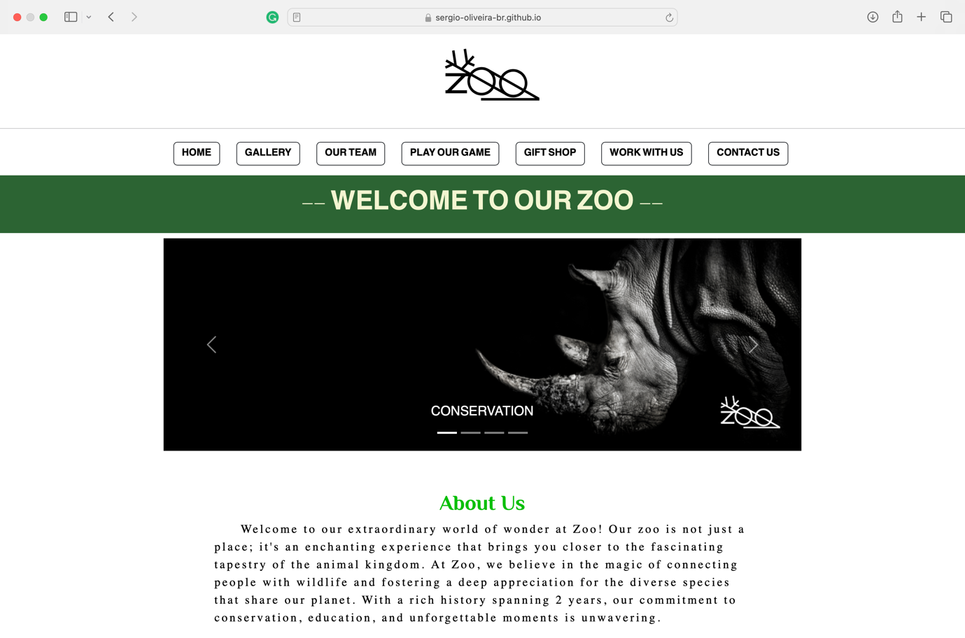

This page is my reflection on my contribution to the project. (Pag2 | Safari & Gallery)

Sergio Oliveira

This page has a js that allows the user to buy a ticket and register feedback.

The button buy, basically starts asking the name of the usual for a personalized service, after this entry the system develops through questions such as for whom the ticket should be named, and age of the owner of the future ticket to be generated.

Finally, an email valid should be input, and a message of thanks and information regarding the ticket were sent to the email entered.

The feedback is broken down into two text entries: name and the feedback itself.

Furthermore, by clicking on the image, it will become larger.

HTML 100%

CSS 100% (except header and footer)

JavaScript 100%

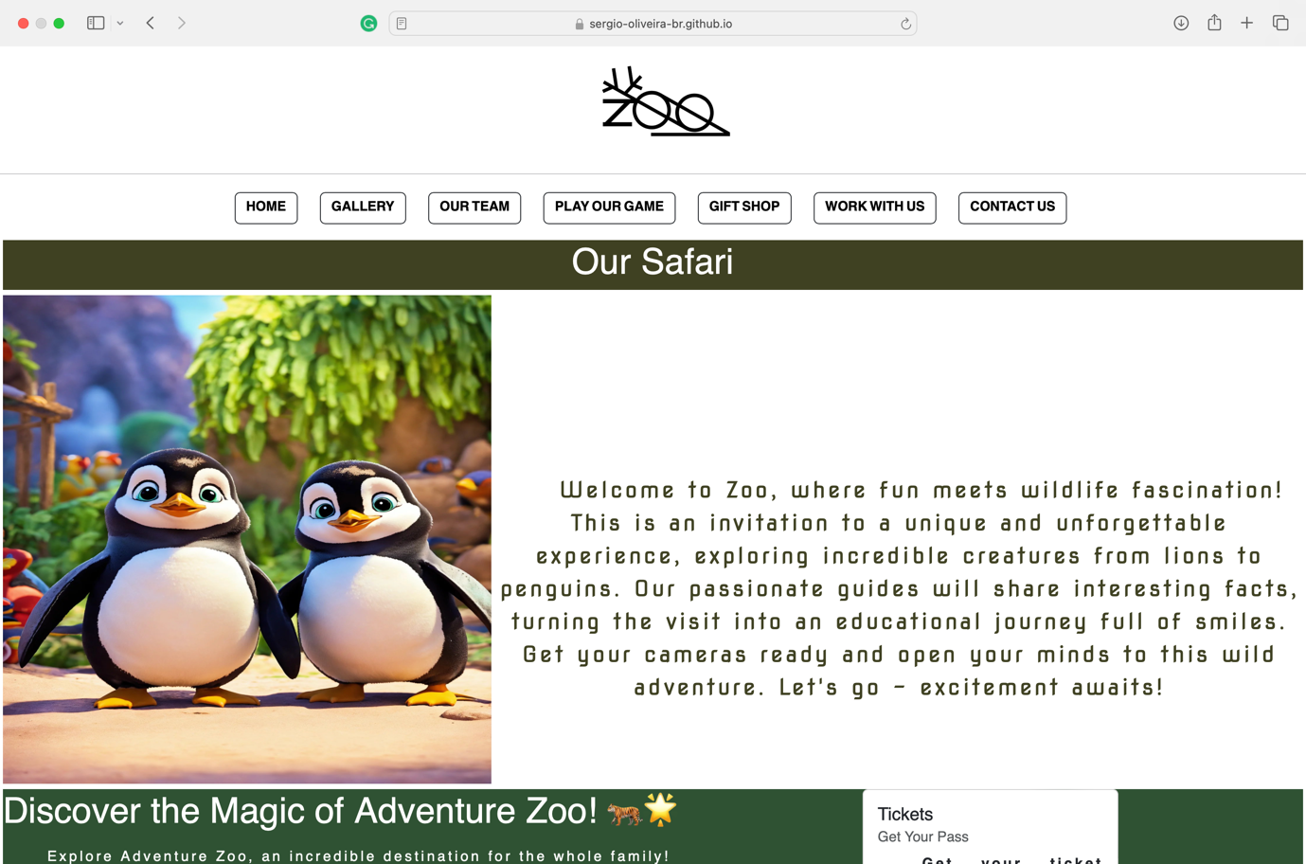

This page is my reflection on my contribution to the project. (Pag 3 |Our Team)

Sergio Oliveira

By using this page, the user can obtain more information about each employee in the images.

HTML 100%

CSS 100% (except header and footer)

JavaScript 100%

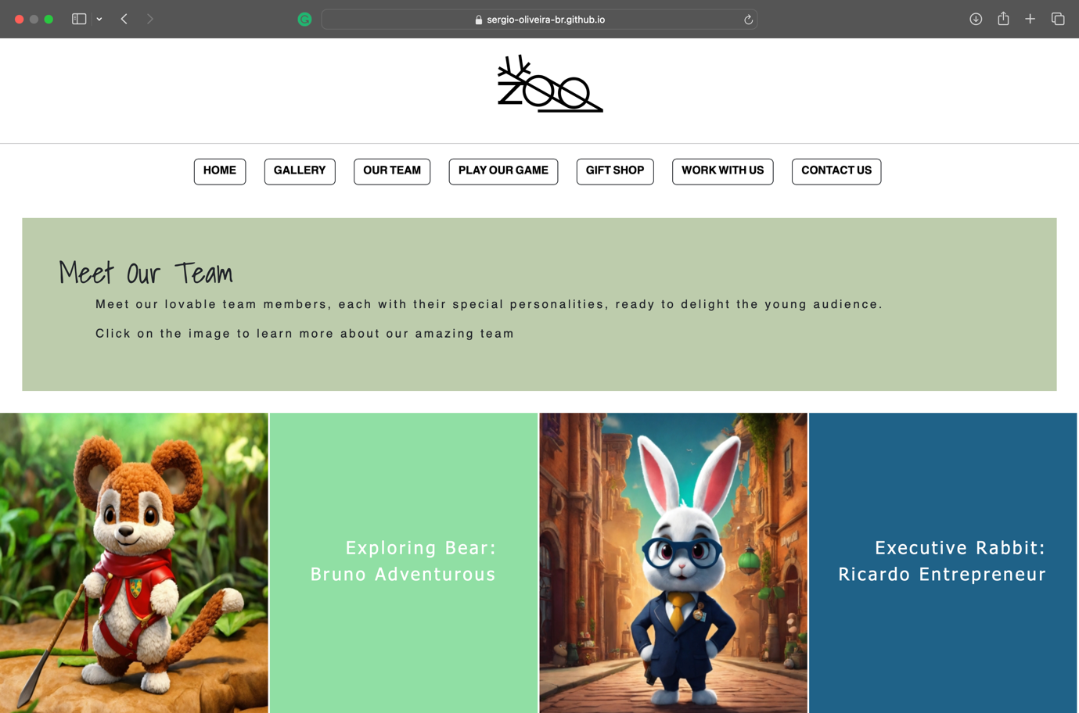

This page is my reflection on my contribution to the project. (Pag3 | Our Team)

Sergio Oliveira

When initializing the page, a popup will appear, if usual close the window, it will be directed to another page.

On the other hand, the user will remain on the same page if they click on the button to check out.

HTML 100%

CSS 100% (except header and footer)

JavaScript 100%

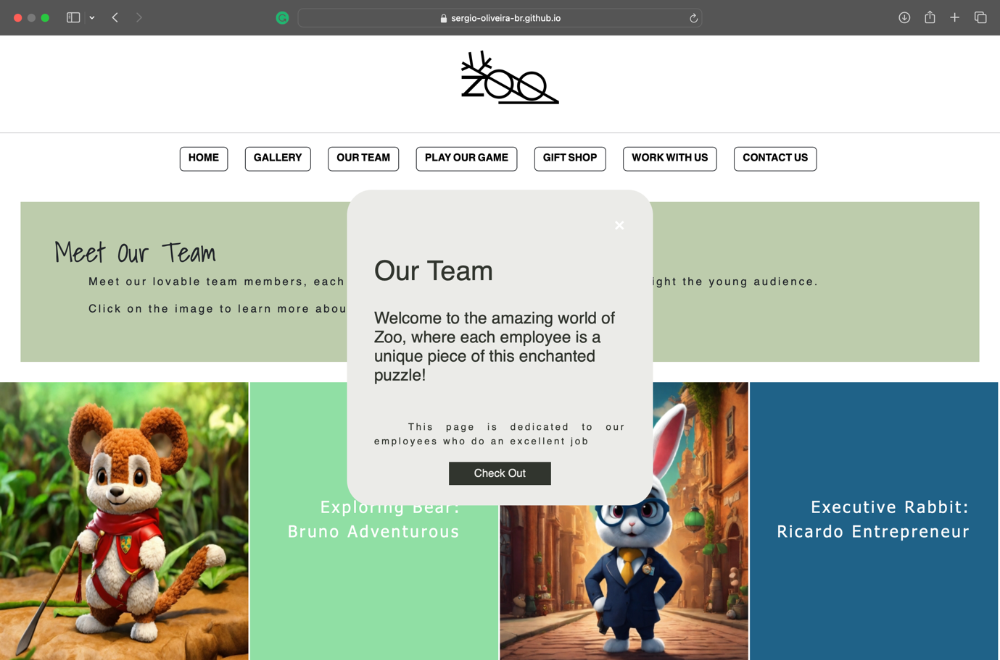

This page is my reflection on my contribution to the project. (Pag 4 | Minigame)

Sergio Oliveira

Guess the number game.

Logic adopted explained via flowchart in this file.

HTML 100%

CSS 100%

JavaScript 100%

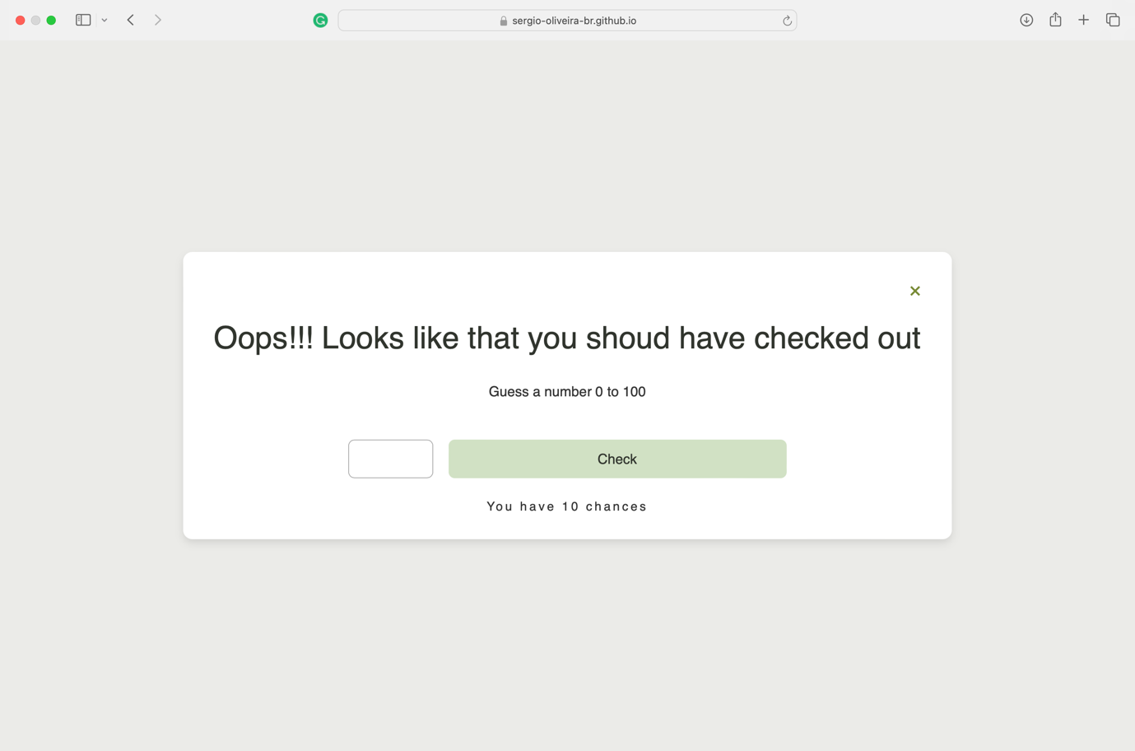

Page developed by Maria Garcia and Sergio Oliveira (Gift Shop)

My contribution was 100% CSS and 100% JavaScript.

This page has a JS that allows users to buy items and finally allows them to identify the total by clicking the Cart button. (should be update by Malu, Price and message)

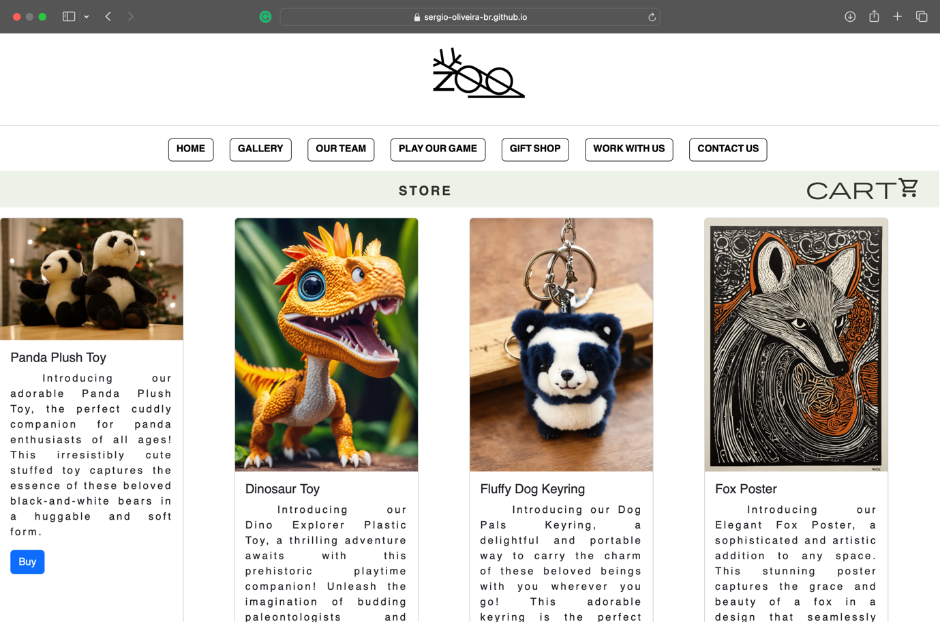

Page developed by Israel Parma (Contact Us)

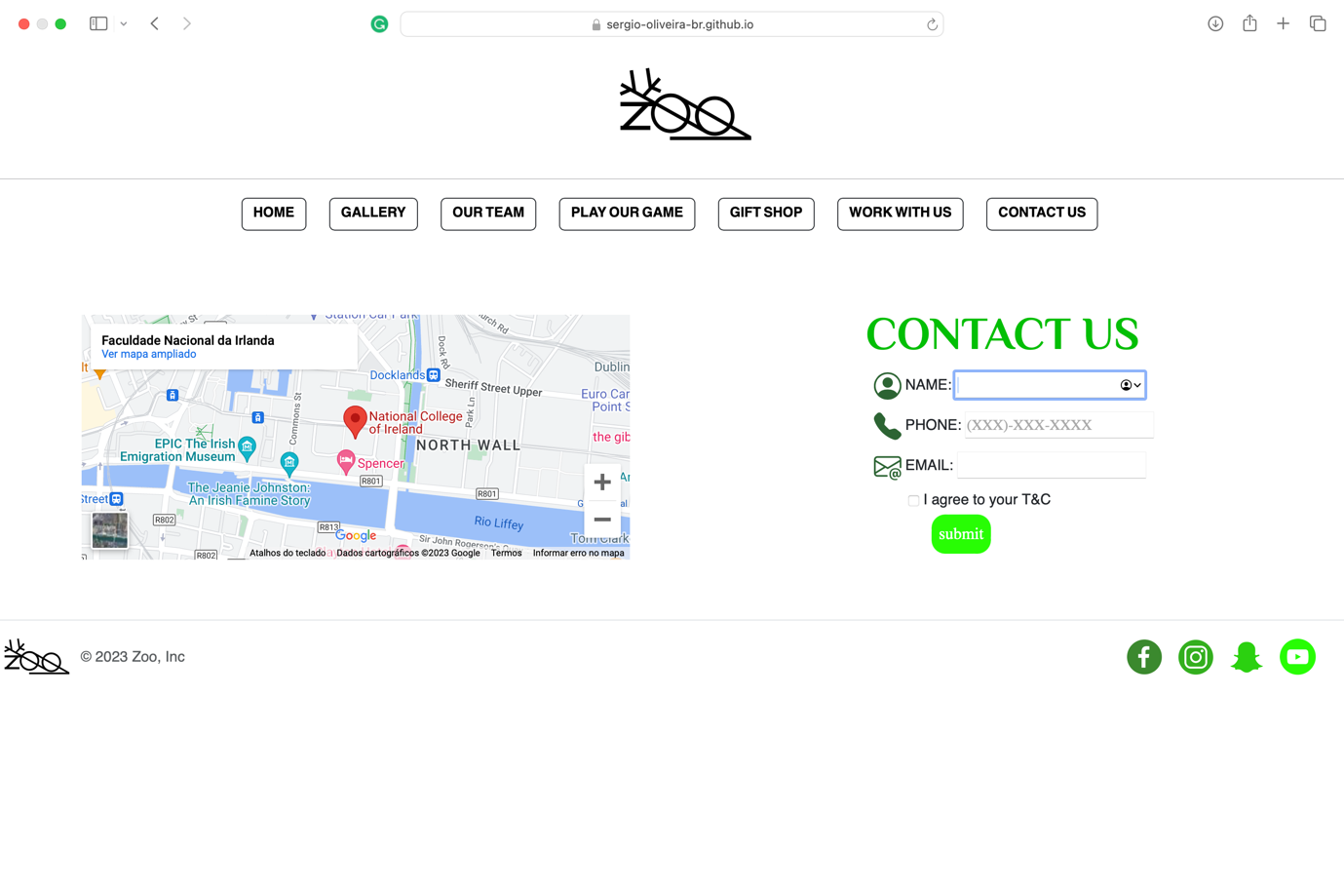

Names of students:

Israel Roberto Parma – [x23175028@student.ncirl.ie](mailto:x23175028@student.ncirl.ie)

Maria Luiza Rodrigues Garcia – [x23157437@student.ncirl.ie](mailto:x23157437@student.ncirl.ie)

~~Nickolas Fernandes Franco -~~ [~~x23146991@student.ncirl.ie~~](mailto:x23146991@student.ncirl.ie)

Israel Roberto Parma – [x23175028@student.ncirl.ie](mailto:x23175028@student.ncirl.ie)

Sergio Vinicio da Silva Oliveira – [x23170981@student.ncirl.ie](mailto:x23170981@student.ncirl.ie)

Date:

07 Dec 2023

Table of Contents

1. Executive Summary ............................................................................................................ 11

2. Project Work ....................................................................................................................... 12

3. Design Process................................................................................................................... 13

4. Testing & Responsiveness ................................................................................................. 26

5. Conclusion .......................................................................................................................... 37

6. References.......................................................................................................................... 27

11 / 37

**1. Executive Summary**

**Why did you decide on this idea, what problem are you solving, what is the market size, etc.?  Provide an overview of your chosen company.**

We chose to follow this idea simply because all the in-group members like animals and nature. Therefore, a zoological park is a perfect combination of these ideas.

<https://sergio-oliveira-br.github.io/NCI-CA-Web-Design/index.html>

<https://github.com/sergio-oliveira-br/NCI-CA-Web-Design>

**2. Project Work**

How did your team split the project work? Show work packages with milestones and deliverables.

Initially, the project included four members, but unfortunately, due to personal problems, Nickolas Franco dropped out of the course.

In this first alignment, as the project requires, we designed something that covered eight pages, following an approach that demonstrated a zoological web page.

* Home / About Us / Overview - Israel
* Night Stroll - Nickolas
* Safari - Nickolas
* **Gallery / Open Word - Sergio Oliveira**
* **Meet our team – Sergio Oliveira**
* Gift Shop - Maria Luiza
* Form / Work with us - Maria Luiza
* Contact us / Map - Israel

After the announcement of the withdrawal of the team members, adjustments were made to adapt to the current reality to meet the project requirements.

The version appended in this report followed the following approach.

* Home / About Us / Overview - Israel
* ~~Night Stroll – Nickolas~~
* ~~Safari - Nickolas~~
* Gallery / ~~Open Word~~ / Safari - Sergio
* Meet our team / Game - Sergio
* Gift Shop - Maria Luiza
* Form / Work with us - Maria Luiza
* Contact us / Map – Israel

Based on this adjusted proposal, we had to mobilize to ensure that all pages we created met all the project's requirements. For this reason, we also had to change the mode of operation, changing the responsibilities, and assigned tasks according to the skills and affinity of each one.

**3. Design Process**

Colour palette, fonts used, buttons used etc. Lots of images and reasons why certain things were done the way they are presented on your website.

The design process was carried out independently by page, which means each page and its respective developers sought their references autonomously. This fact has provided us with an evolution of our understanding of teamwork.

In short, as we evolved in the assigned design phase, colour, font, and images, we realized that an initial alignment was essential so that we could promote harmony between the pages.

Facing the zoo theme, we sought images to allude to the proposal, therefore, Lexica.Art and Designer.Microsoft.com, were the references used in image acquisition. It comes to mind that ImageOptimizer.net optimized all images. The images were contextualized with the help of Chat.OpenAI.com.

In possession of the images, Canvas.com Colour Pallets helped us with the association and colour assignment of the pages.

We use W3Schools.com and GetBootstrap.com. In addition to the materials presented in the classroom to build the pages.

Regarding the choice adopted for the JavaScript minigame, it is due to the reason that we had already done it during the software development classes. Furthermore, we have achieved a significant reduction at this stage of development.

Web Page - <https://lexica.art>

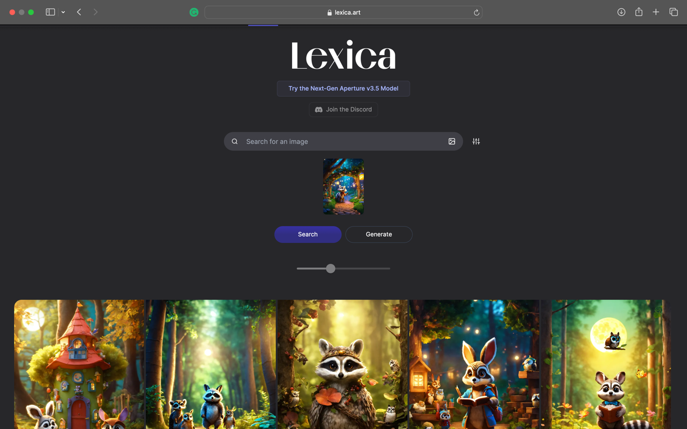

Web Page where we got images.

Designer Microsoft - <https://designer.microsoft.com>

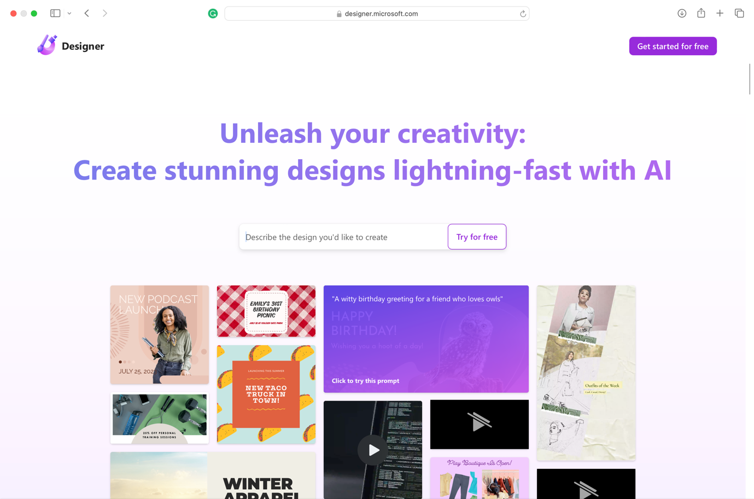

Web Page where we got colours.

<https://www.canva.com/colors/color-palette-generator/>

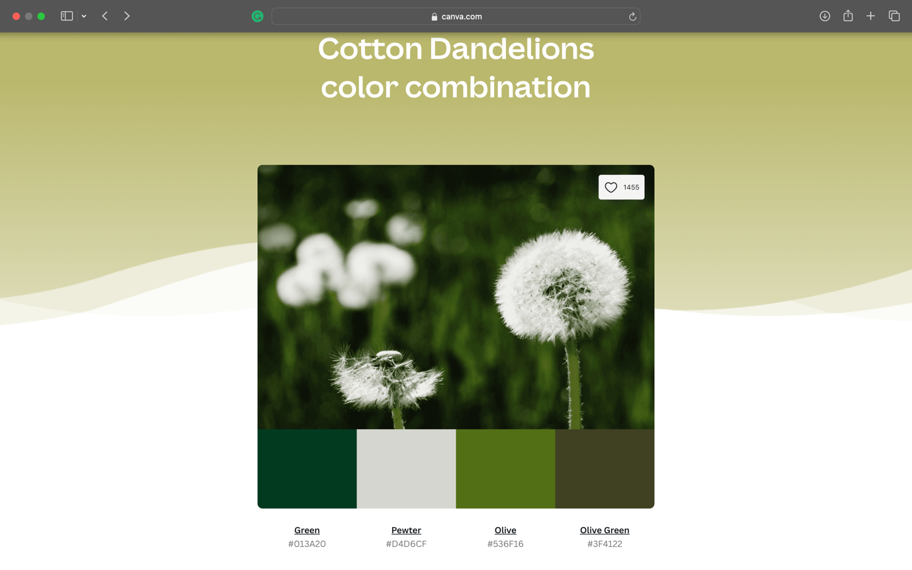

Web Page NCI – Moodle Page where we got the game idea. <https://moodle2023.ncirl.ie/course/view.php?id=1053&section=4#module-20092>

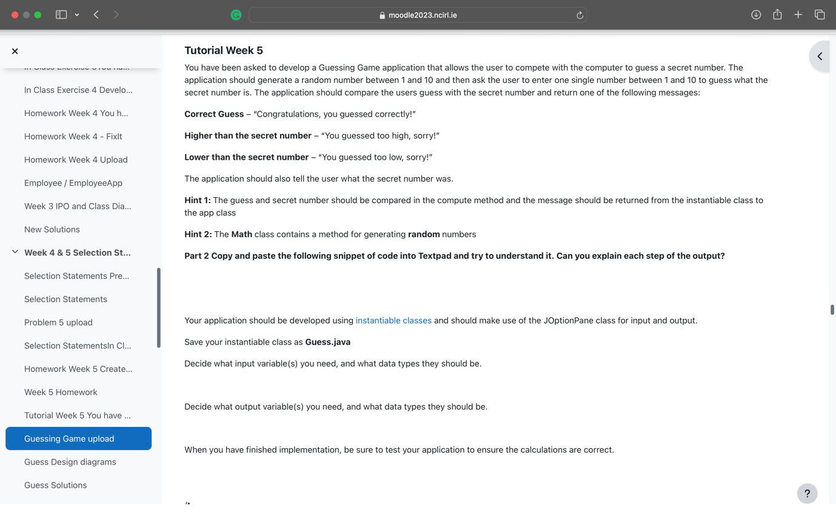

Web Page – Bootstrap where we got forms.

<https://getbootstrap.com>

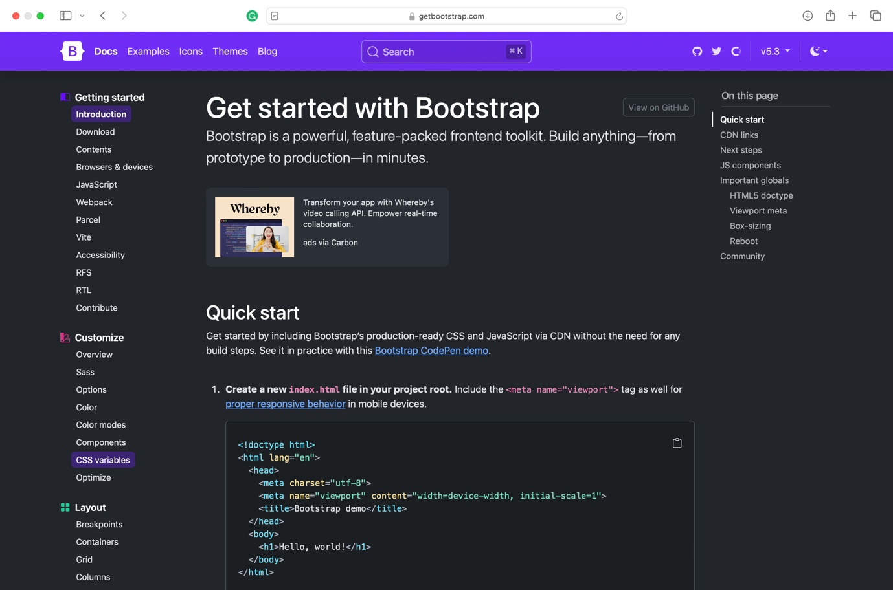

Web Page W3 where we got forms.

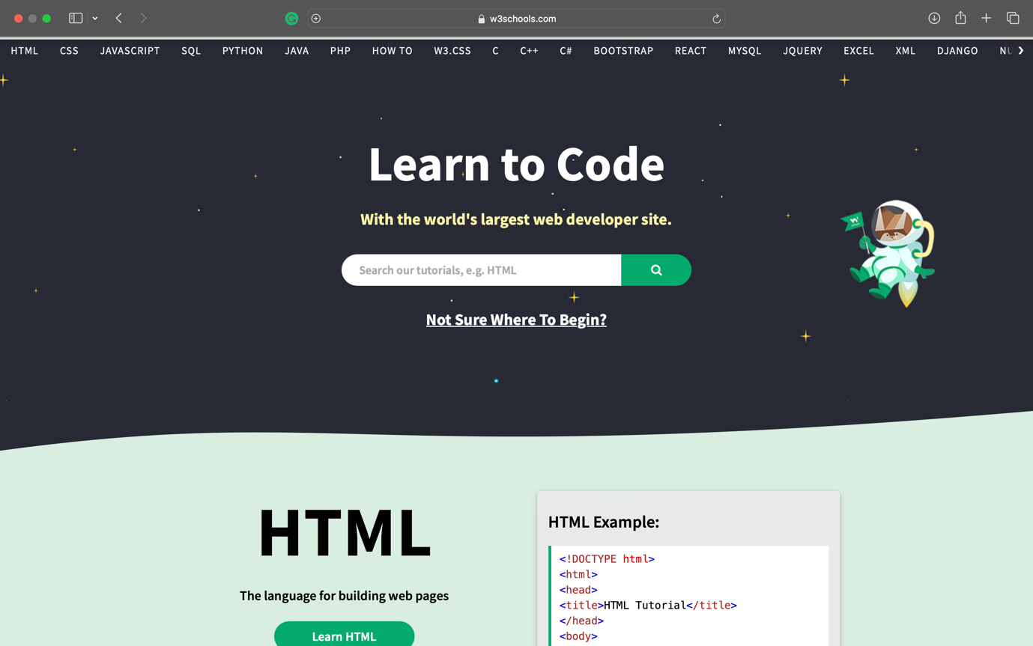

Wireframe – Index Page by Sergio Oliveira.



Wireframe – Page Gallery & Safari by Sergio Oliveira.



Wireframe – Page Our Team (popup) by Sergio Oliveira.



Wireframe – Page Our Team by Sergio Oliveira



Wireframe – Game by Sergio Oliveira

Wireframe – Gift Shop by Sergio Oliveira



Wireframe – Contact Us by Sergio Oliveira



**4. Testing & Responsiveness**

Talk about website responsiveness here along with **Optimisation, SEO and Testing**.

As mentioned earlier, the web page is available online and has been implemented through GitHub.

The documents used to create the pages are accessible through <https://github.com/sergio-oliveira-br/NCI-CA-Web-Design> in a public repository.

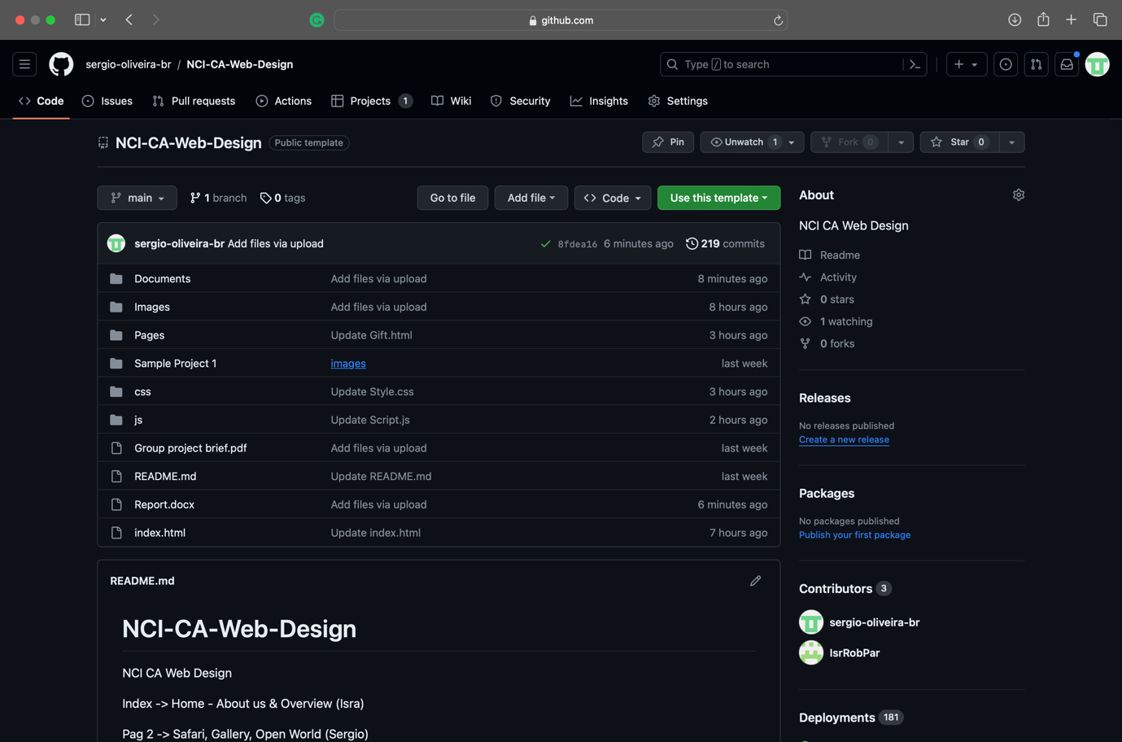

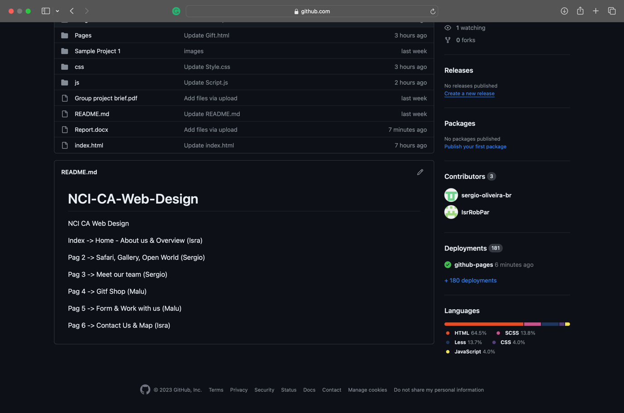

In accordance with the project scope, all images were optimized to achieve the desired responsiveness.

Pages Speed has provided reports below to support this statement.

<https://pagespeed.web.dev/analysis/https-sergio-oliveira-br-github-io-NCI-CA-Web-Design-index-html/gocm501h16?form_factor=mobile>

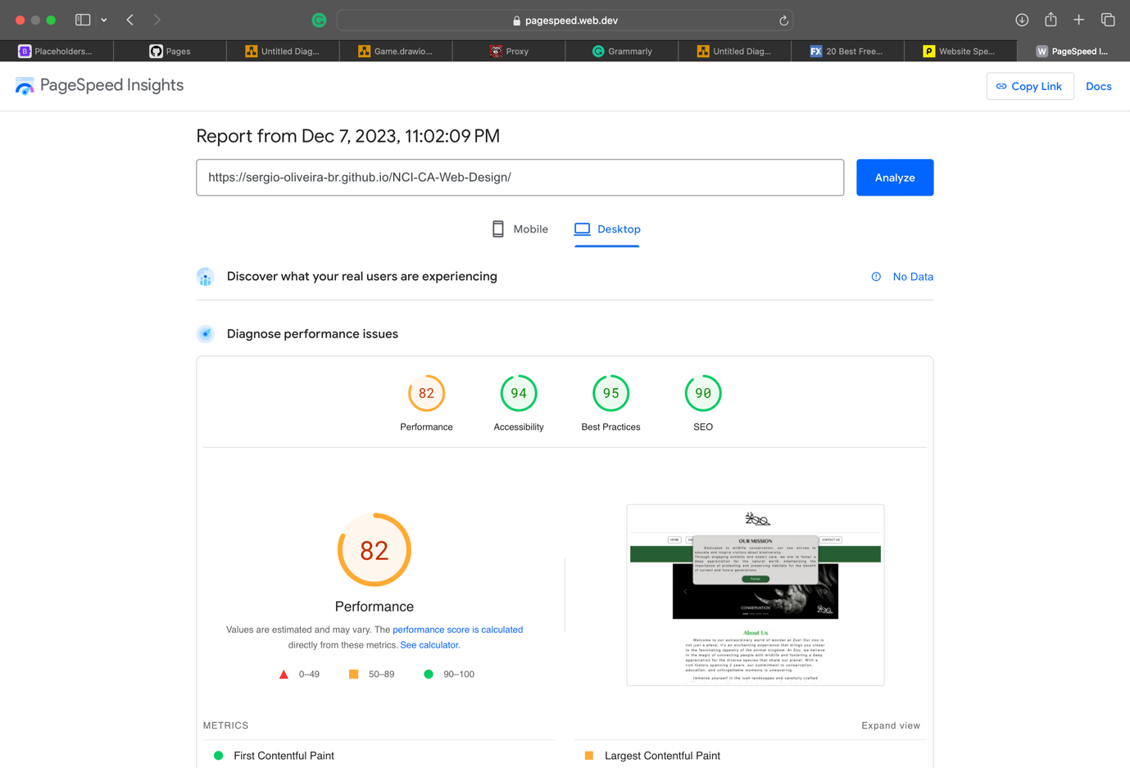

<https://pagespeed.web.dev/analysis/https-sergio-oliveira-br-github-io-NCI-CA-Web-Design-Pages-Gallery-html/6dnfguf6hp?form_factor=desktop>

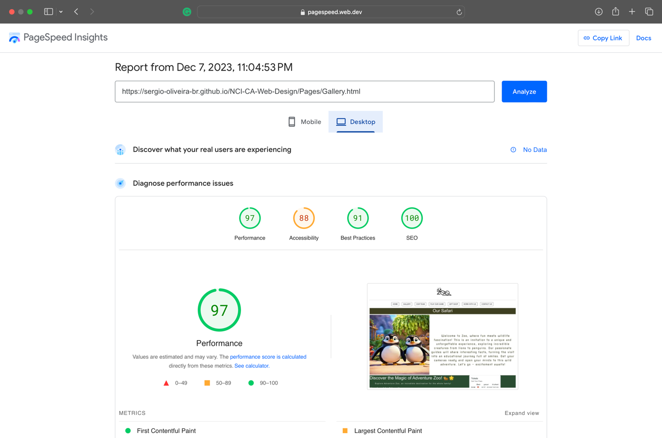

<https://pagespeed.web.dev/analysis/https-sergio-oliveira-br-github-io-NCI-CA-Web-Design-Pages-OurTeam-html/hel0je1qdf?form_factor=desktop>

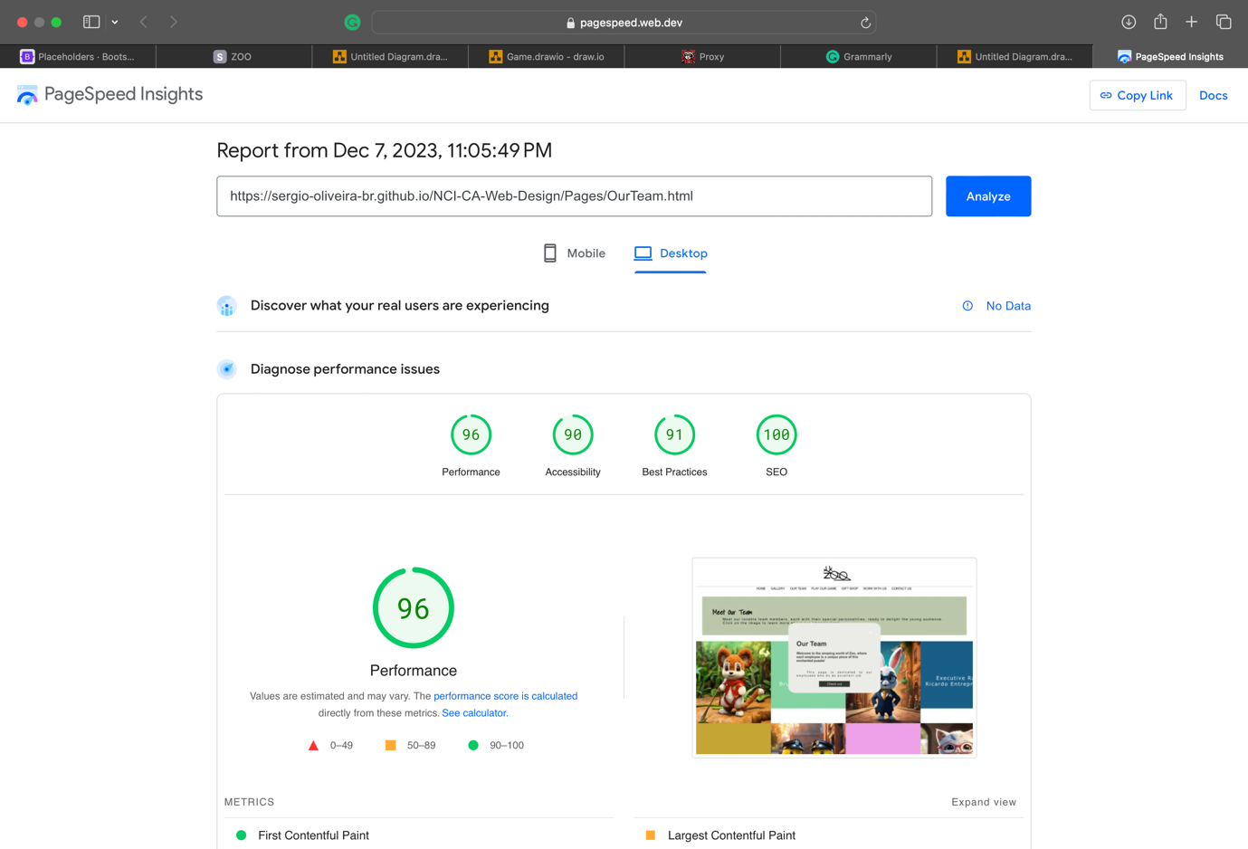

<https://pagespeed.web.dev/analysis/https-sergio-oliveira-br-github-io-NCI-CA-Web-Design-Pages-Game-html/4rmjp500vs?form_factor=desktop>

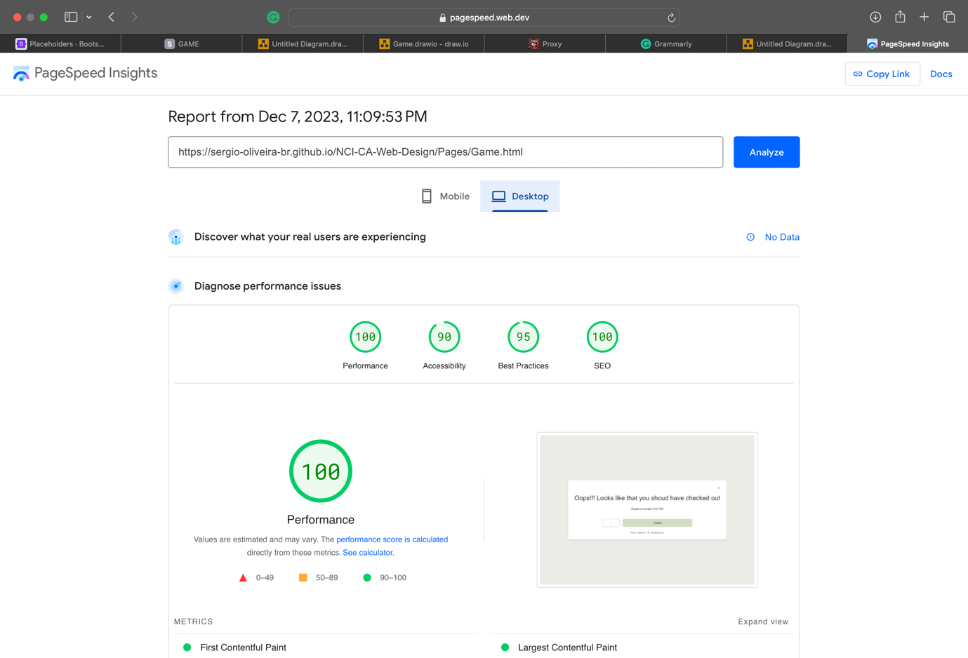

<https://pagespeed.web.dev/analysis/https-sergio-oliveira-br-github-io-NCI-CA-Web-Design-Pages-Gift-html/55ghj2xzxj?form_factor=desktop>

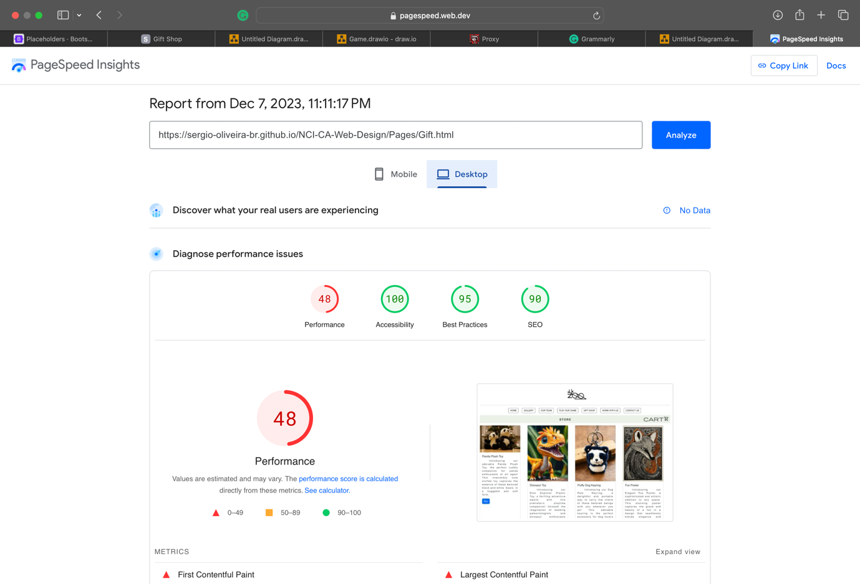

<https://pagespeed.web.dev/analysis/https-sergio-oliveira-br-github-io-NCI-CA-Web-Design-Pages-ContactUs-html/y3ufh3j2ds?form_factor=desktop>

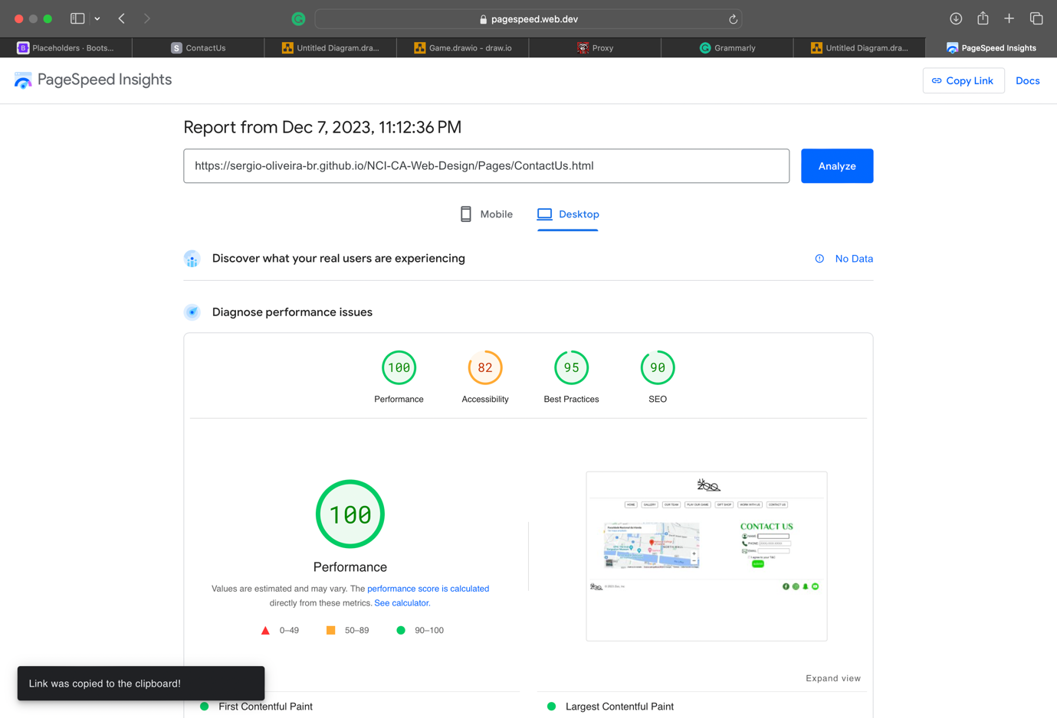

Page – Gallery | Flowchart of the buy button by Sergio Oliveira

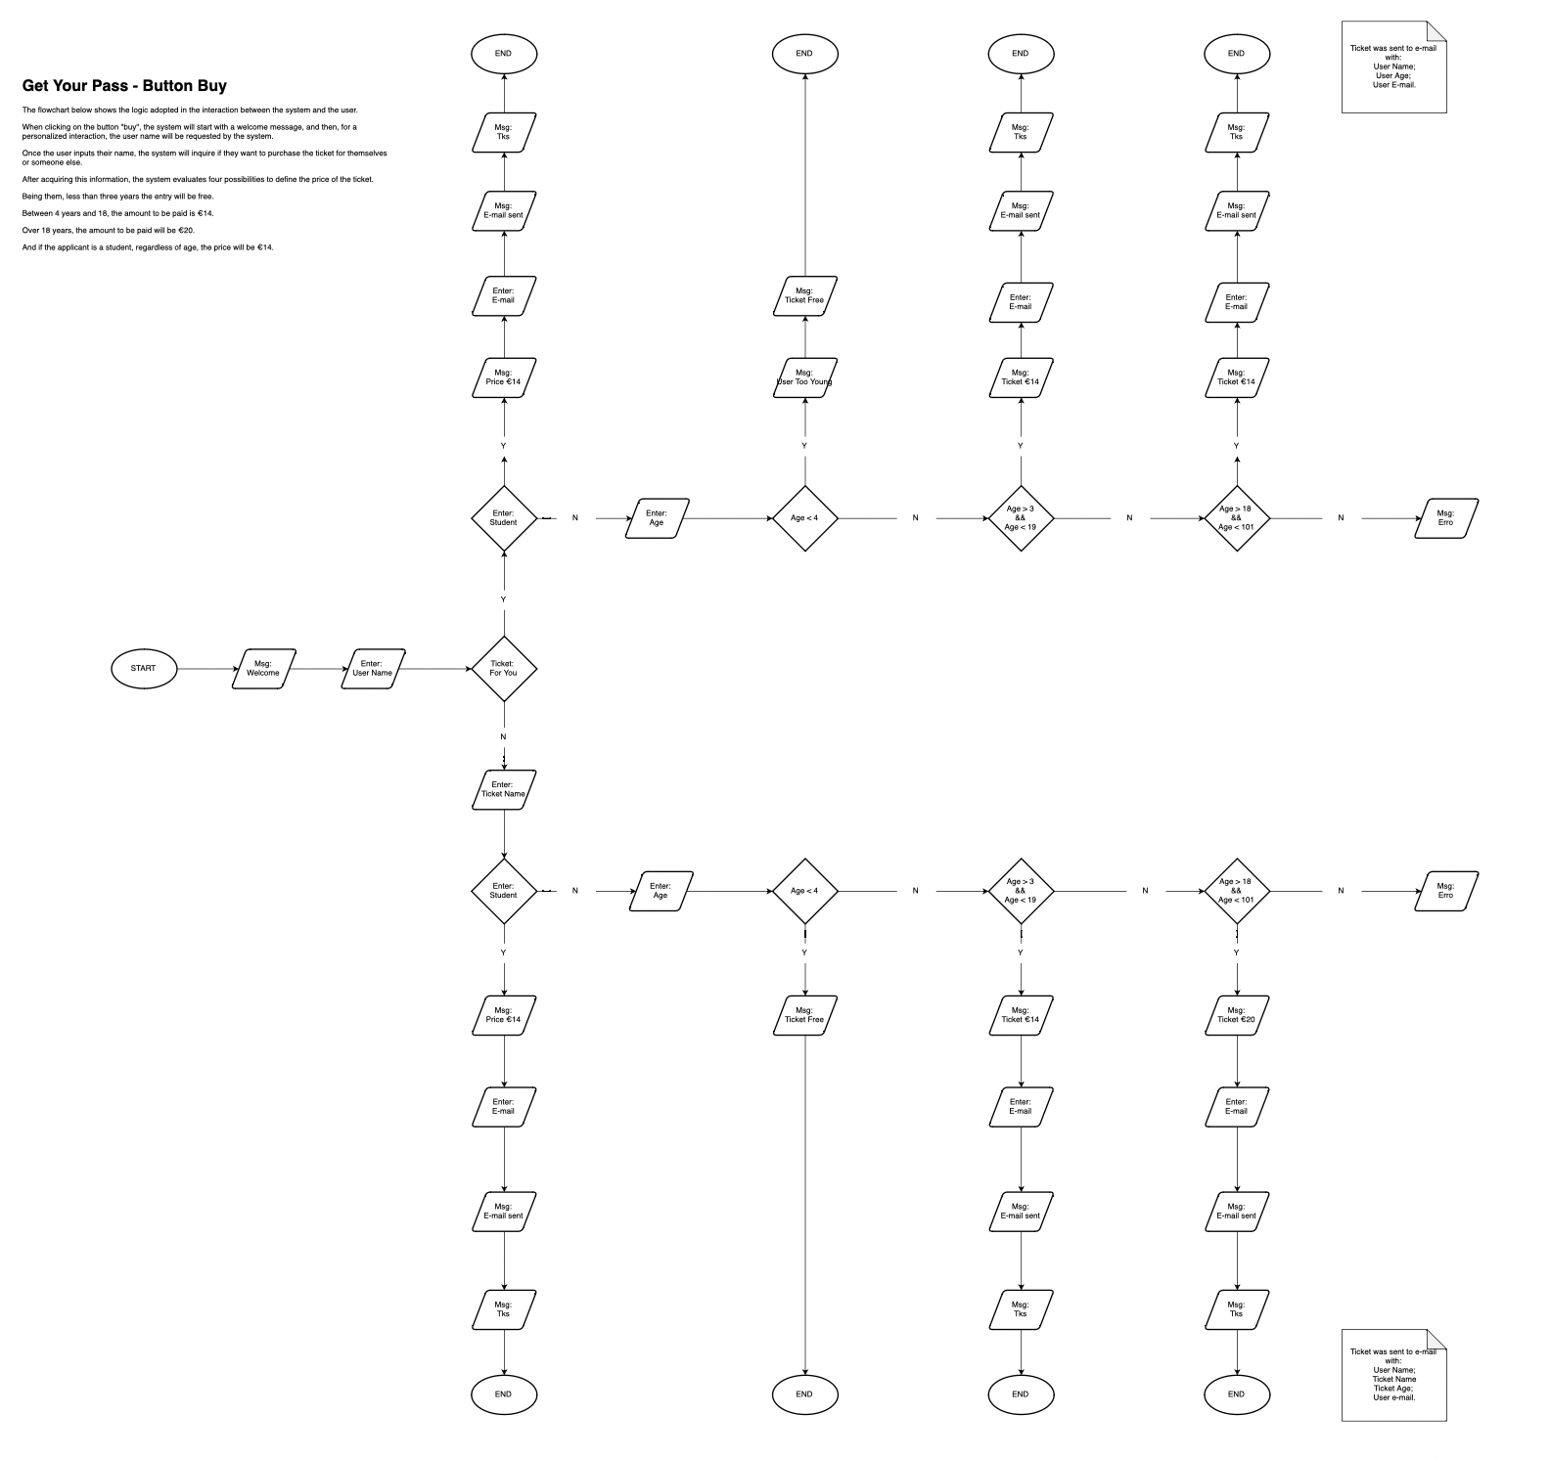

Page Gallery | Flowchart of the boot feedback by Sergio Oliveira



Flowchart – Game by Sergio Oliveira

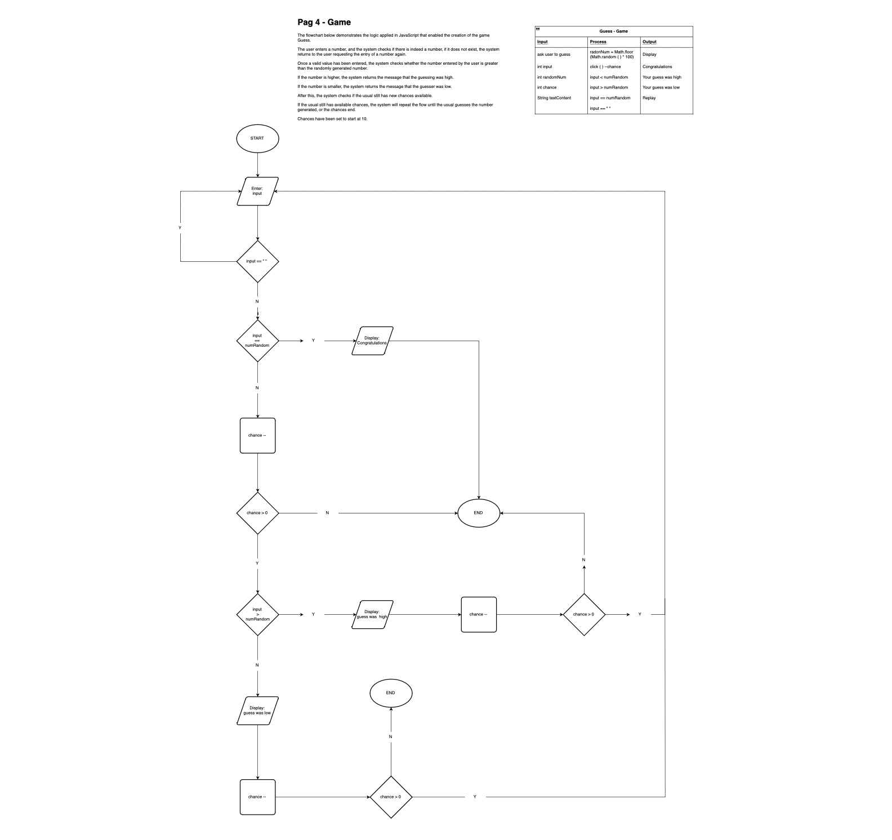

**5. Conclusion**

Overview of how the project went, did you work together well as a team? What was difficult to do, how you feel the website looks and if you had time, would you make any changes?

As mentioned earlier, due to the loss of a team member, the project has undergone some significant changes. However, the team was able to adjust to the current reality and deliver the project on schedule with the expected expectations and quality.

As a matter of grandeur, the team pushed more than 400 commits in all branches of the project. The team's hard work and commitment resulted in more than 3600 additions.

During the movements performed, we realized the lack of an initial alignment. For this reason, among all the learnings acquired, we highlight the communication and alignment at the early stage of development. Given the absence of these, we note the opportunity for harmonization between the pages.

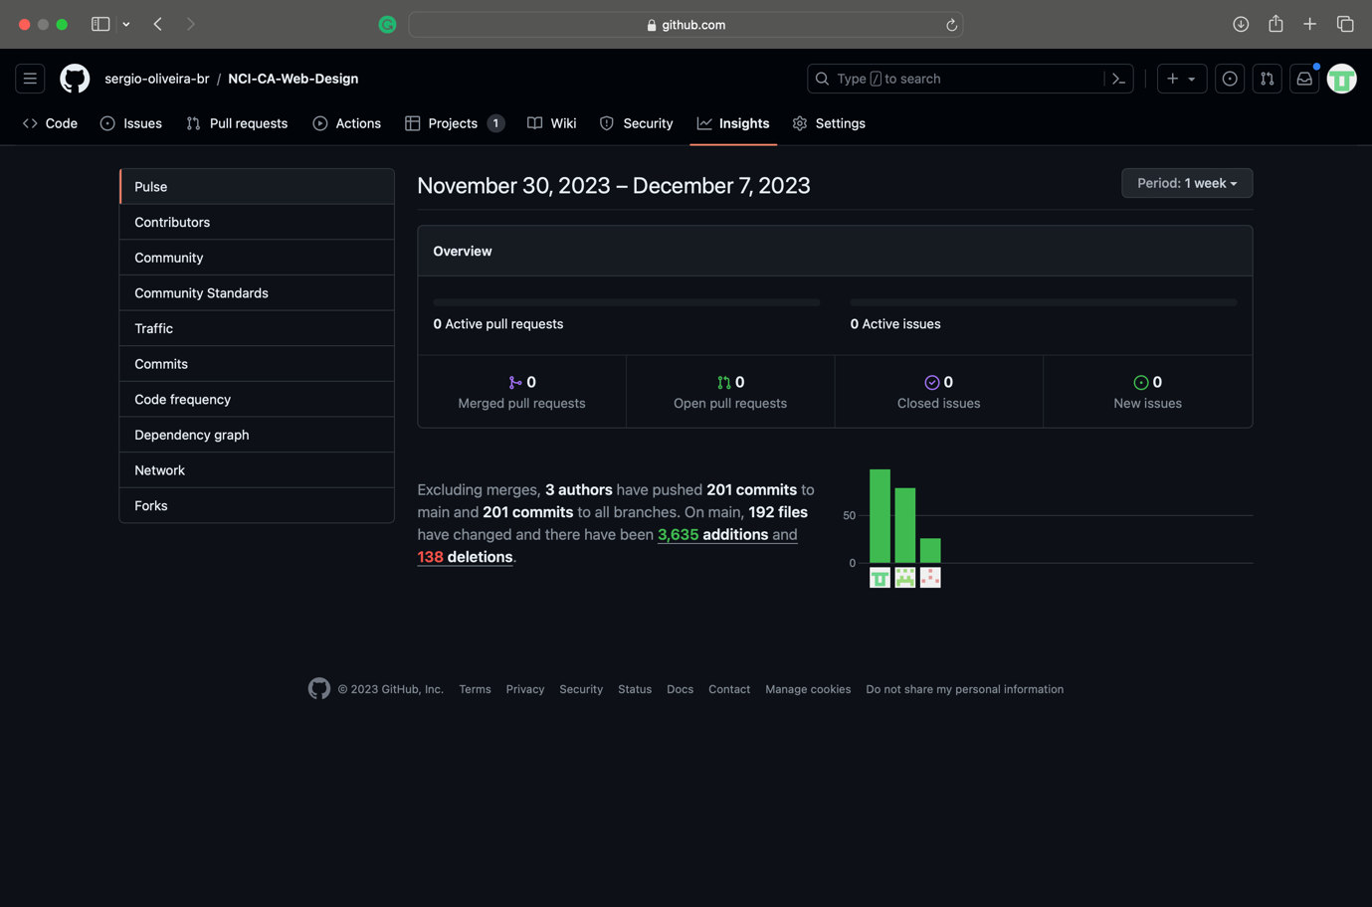

37 / 37

**6. References**